Race Info

Race:

Date of Race:

Location of Race:

Typical/Predicted Weather for Race Day (temp., humidity, dew point, wind):

Course Profile (altitude of race venue, elevation gain on course, technicalities, etc.):

Plans Leading up to the Race Day

Travel to Race Venue:

Check-In:

Day Before Food:

Race Day

Wake-up:

Breakfast:

Get to Race Start

Warm-up:

Start Time Plans:

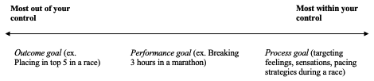
Goals/Planning

General Expectations for Race Day:

Primary Goal/Focus:

Outcome Goals

Performance Goals

Process Goals

- {{Time}}
- {{Strategy}}
- {{Fueling}}

Post-Race Recovery:

